MAT1033C Intermediate Algebra Name __________________
Please time yourself, take this quiz and write a self-reflection essay using the space provided below.
Starting time:_________
Ending time:__________
Total time spent:_________minutes

_______________________________________ ________________________
Student Signature Date

Quiz 1
- Simplify the expression: −4[5 -3(−4 + 9)] + 15

Part I | Part II | Resources Used, if any

2. Simplify the arithmetic expression: $\frac{5}{15 }+\frac{7}{20}$
Part I | Part II | Resources Used, if any

3. Solve the equation: 7( - 𝑥 + 1) = −2(𝑥 − 4) +3 𝑥
Part I | Part II | Resources Used, if any

4. Evaluate the expression 𝑥² − 3𝑦𝑧 + 2(𝑥 + 𝑦) for 𝑥 = −2, y = 3, 𝑧 = −1.
Part I | Part II | Resources Used, if any

5. Simplify the polynomial: (3𝑥² + x - 5)(2𝑥 − 6) − (2𝑥)(𝑥² − 3𝑥 − 4)
Part I | Part II | Resources Used, if any

6. A television is on sale for $720. If the sale price is 10% less than the regular price, what was the regular price?
Part I | Part II | Resources Used, if any

7. Solve the equation for y: $2x + \frac{5}{6}y - 1 = 4 +2 x$
Part I | Part II | Resources Used, if any

8. Factor the trinomial: $2x^{2} - 13x + 6$
Part I | Part II | Resources Used, if any

9. Find the x- and y-intercept of the linear equation 6𝑥 − 3𝑦 = −18, and write your answers as ordered pairs.
Part I | Part II | Resources Used, if any
10. Graph the line with a slope of $-\frac{2}{3}$ and the y-intercept at (0,4), and write the equation of this line in slope-intercept form.
Part I | Part II | Resources Used, if any
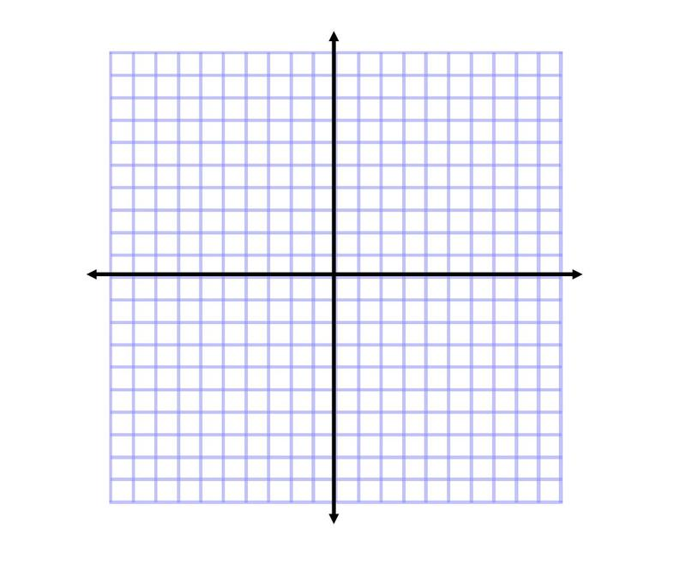
Equation:

